

**CA3 Project Plan Submission**

**Name:** Chai Pin Zheng

**Objective of the website:**

As the Covid-19 pandemic sweeps over the world, more and more businesses are adapting and pivoting to a new “business” model to minimize the health risk associated with customers and employees being in close physical contact. This had forced a large magnitude of employees into remote working structures or facilitate online interactions between customers and businesses. As such, with this sudden change from a “9-5 desk job” to work from home “staycation”, many people are freer and can surf the web, however, with more data, how much of their privacy is valued or how many of users’ data are being intercepted by hackers?

Atlas aims to be at the frontline with their VPN designed with the new revolutionary proprietary “curve 25519” encryption algorithm to help individuals stay protected from hackers and online thieves. The website will be the platform for any individuals, to browse through our catalogue of security packages we employ. Others include:

* A high quality customer enquiry system, enabling feedback or queries to be asked
* Being as user friendly as possible, so to pivot ourselves as capable and professional
* Having a News page, to alert users of recently discovered exploits and security flaws

**Target Audience:**

The persona below represents the target audience:

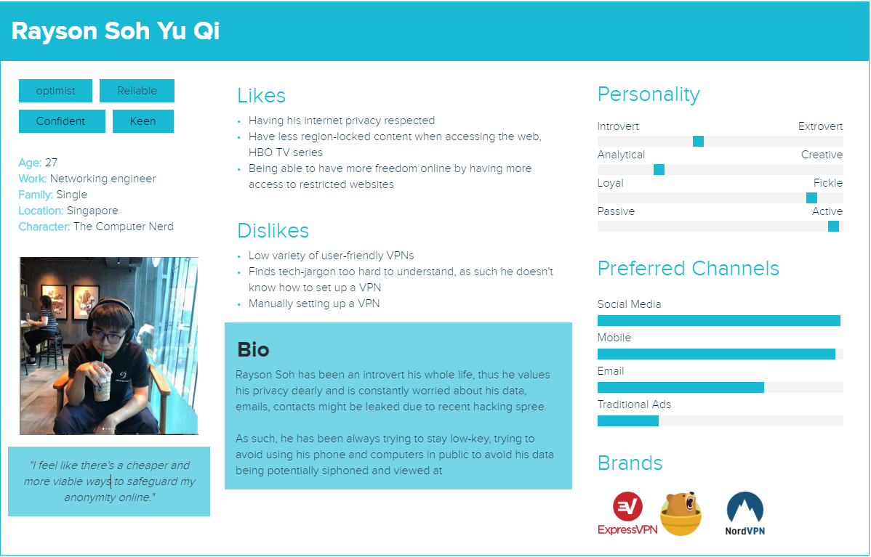

|  |  |
| --- | --- |
| 1. **Home**   (Index.html) | * Promotional Advertisements, persuasion on why to get a VPN, testimonials |
| 1. **What is a VPN?**   (subpage) | Consist of:   * Information about VPNs * How VPNs encrypt your file, such as it giving anonymity and protection against malicious actors * Benefits of a VPN * When should the user use a VPN |
| 1. **Pricing**   (subpage) | Consist of:   * The different variety of packages they can get, such as a single version, a freemium version and a family package deal * A small testimonial to let people know why we Atlas is the best * Small section devoted to listing reasons why our VPN is the choice to go with. |
| 1. **Servers**   (subpage) | Consist of:   * The list of different and vast amount of servers that Atlas has all across the world/continent. * Such as having servers in the Asia pacific and giving a list of different servers * Find the best server * Server features such as having unique specialty |
| 1. **Help**   (subpage) | Consist of:   * Issue form * Customers/buyers can give their feedback and opinion such as suggestions for the future build of the VPN or voicing their issue with the app. * Popular support topic * Assist in providing links to already solved questions to popular questions, adding users to navigate more easily |

Sitemap:

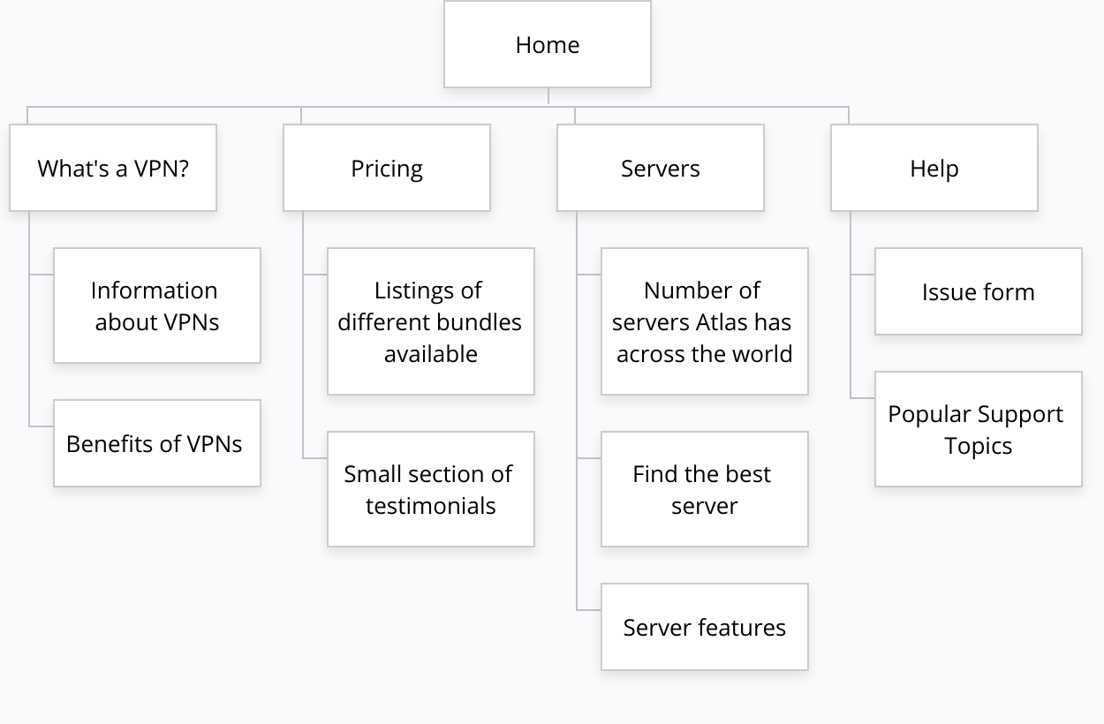

Wireframe 1:

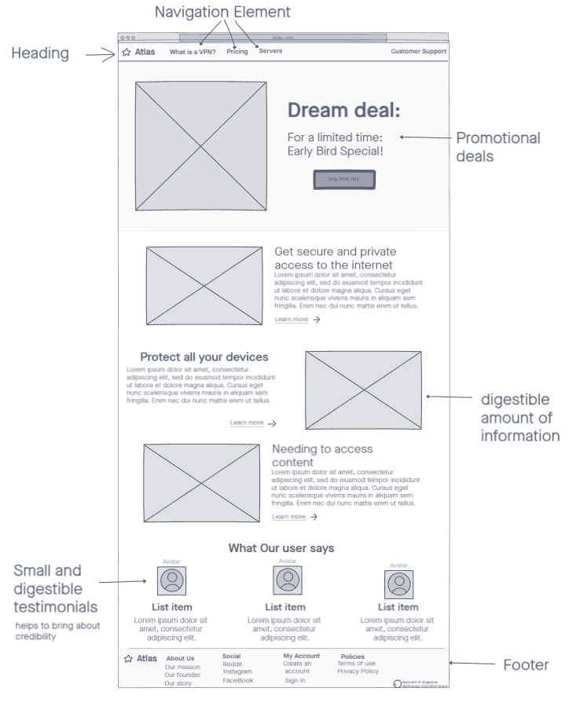

Wireframe 2:

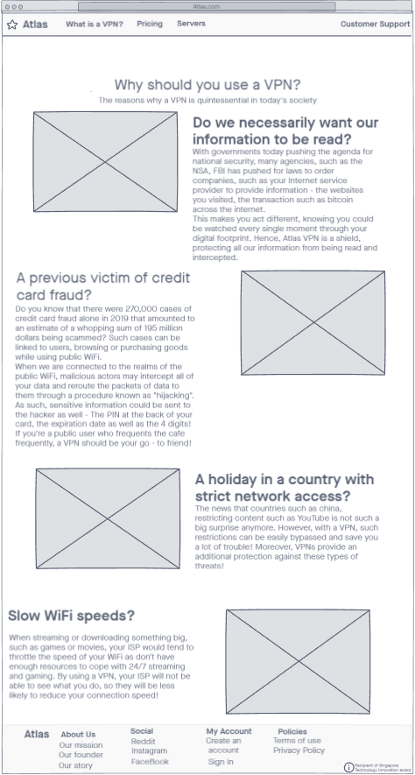

Wireframe 3:

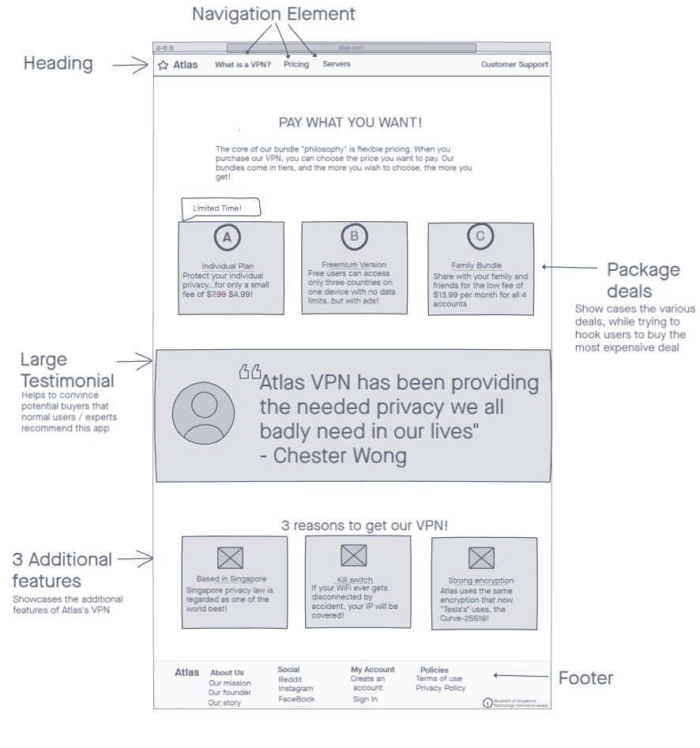

Wireframe 4:

: 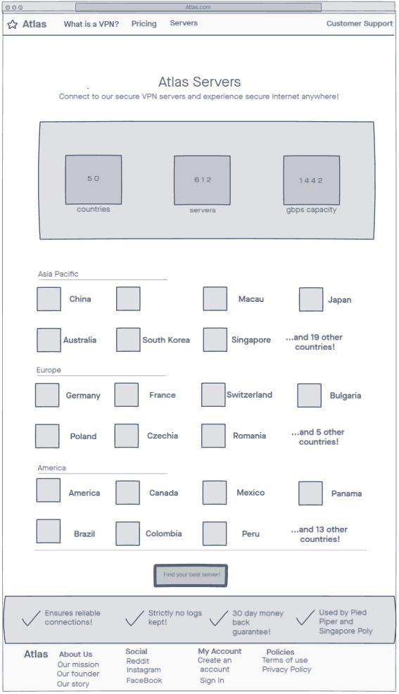

Wireframe 5:

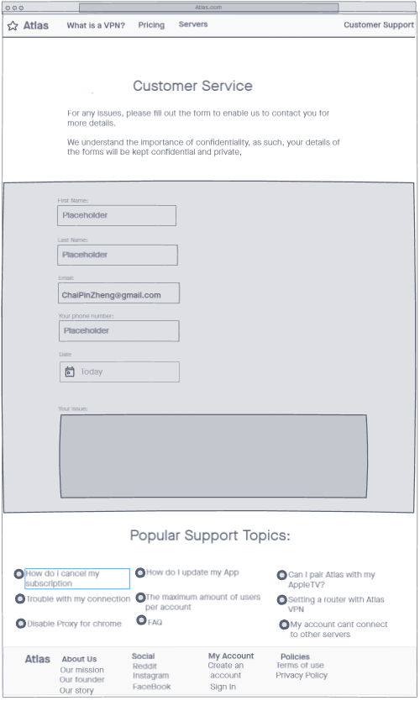

**References:**

<https://www.expressvpn.com/>

<https://nordvpn.com/>

<https://www.tunnelbear.com/>